- Visit https://marlin.pilotfishtechnology.com:9443/
(Note the HTTPS and port 9443 this portal is only accessible from our internal network)
(Note at the time of writing you may receive a certificate error)

- Add certificate to browser.

Firefox: Link
Safari: Link
Chrome: Link

- If you are directly connected to the CT office network, please visit:
https://10.1.10.240:943/?src=connect

- Click the dropdown menu and select Login and then continue logging into the portal using the openvpn credentials provided to you separately (Fig1)

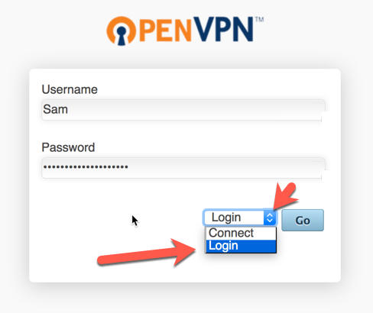
Figure 1 Login

- Download the client for your device/OS (Fig2) (Note: you may need to download your connection profile manually if the installer does not automatically install with it.)

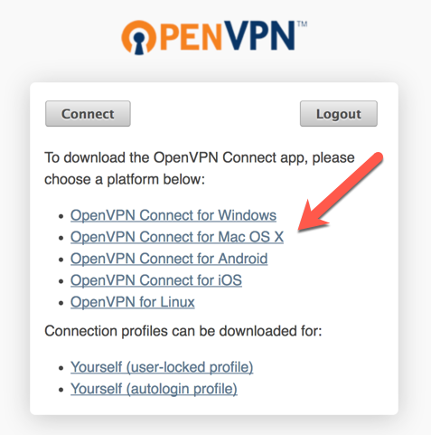
Figure 2 Download Client

- Client install on MAC.

- Locate the installer it will have a name like (openvpn-connect-X.X.dmg) most browsers will put it in the downloads folder by default. (Fig3-5)
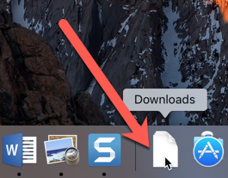
Figure 3 Downloads Folder
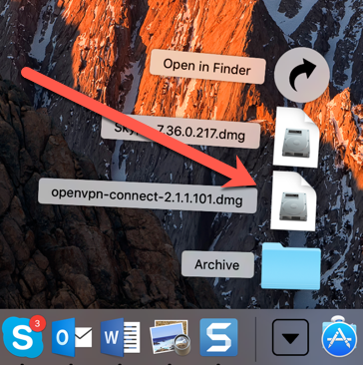
Figure 4 Click
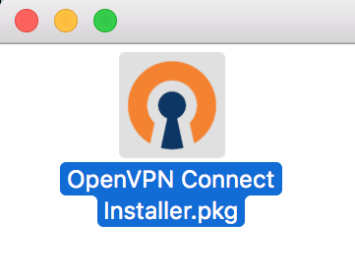
Figure 5 Right Click

- right click and select Open With Installer (Fig6) (Note: this may be required to install the package as it is from an unknown source)

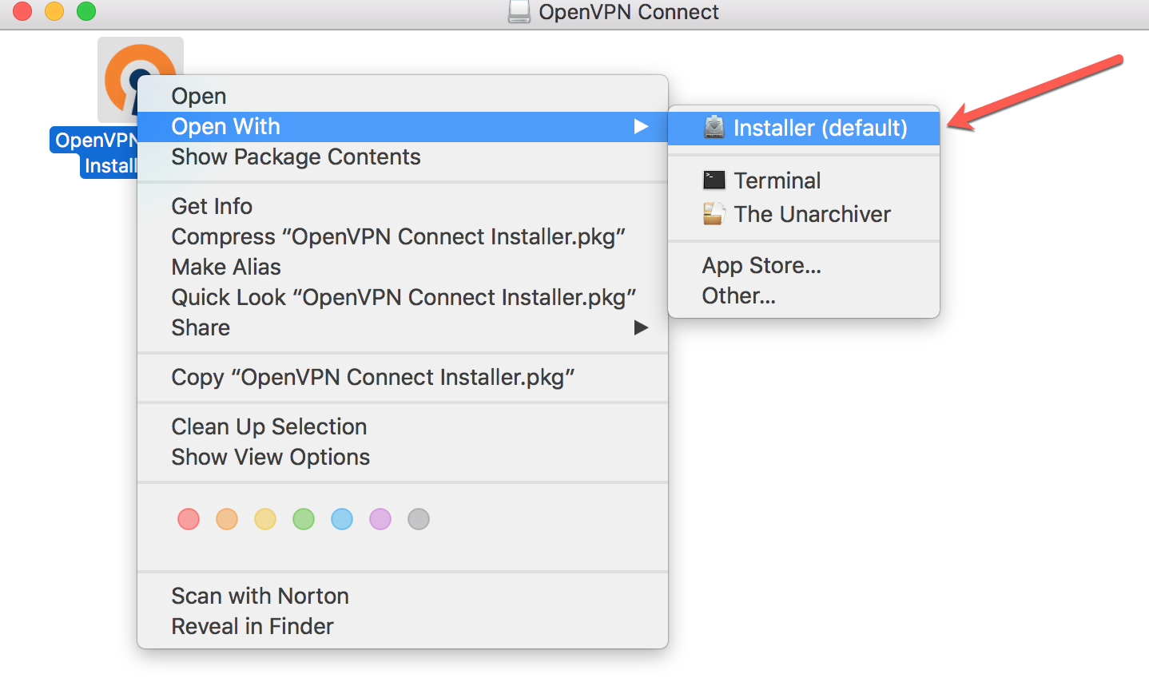
Figure 6 Right Click

- Accept security warning. (Fig7)

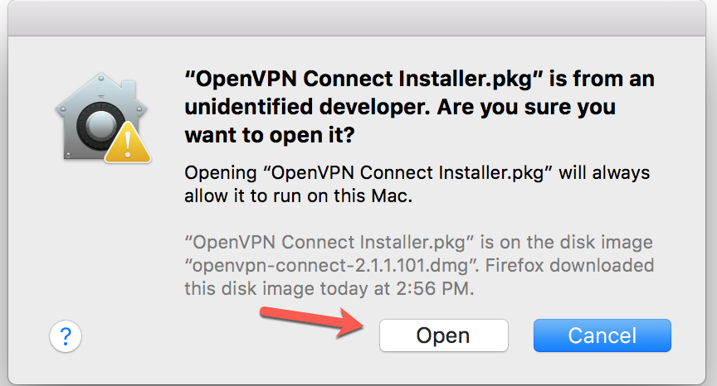
Figure 7 Open

- Proceed with installation. (Fig8-14)

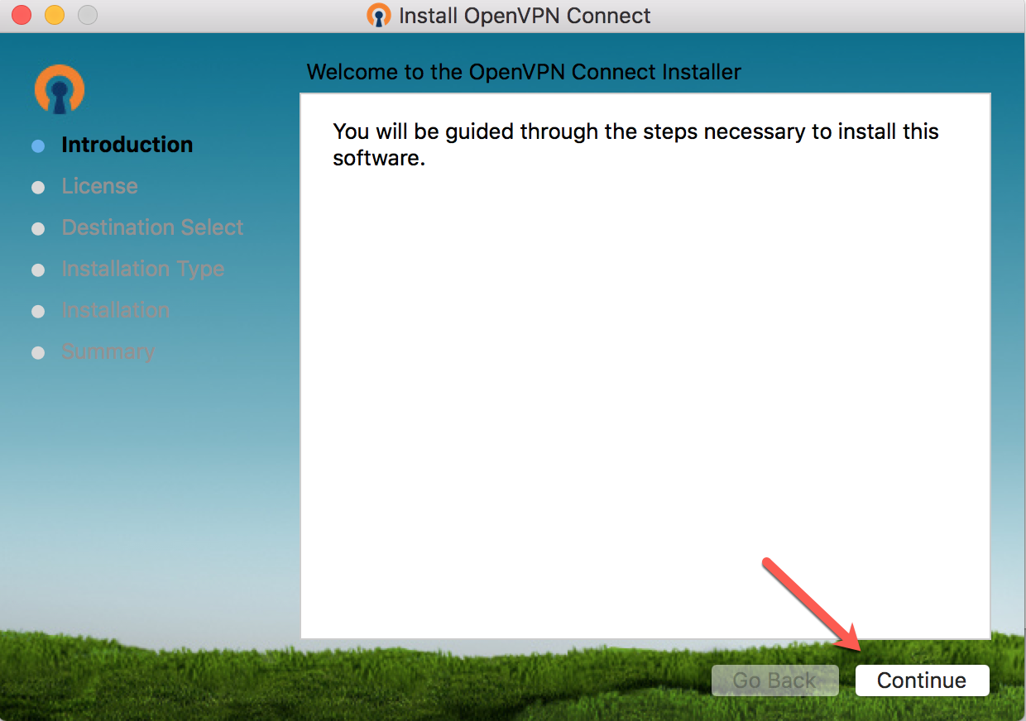
Figure 8 Click Continue

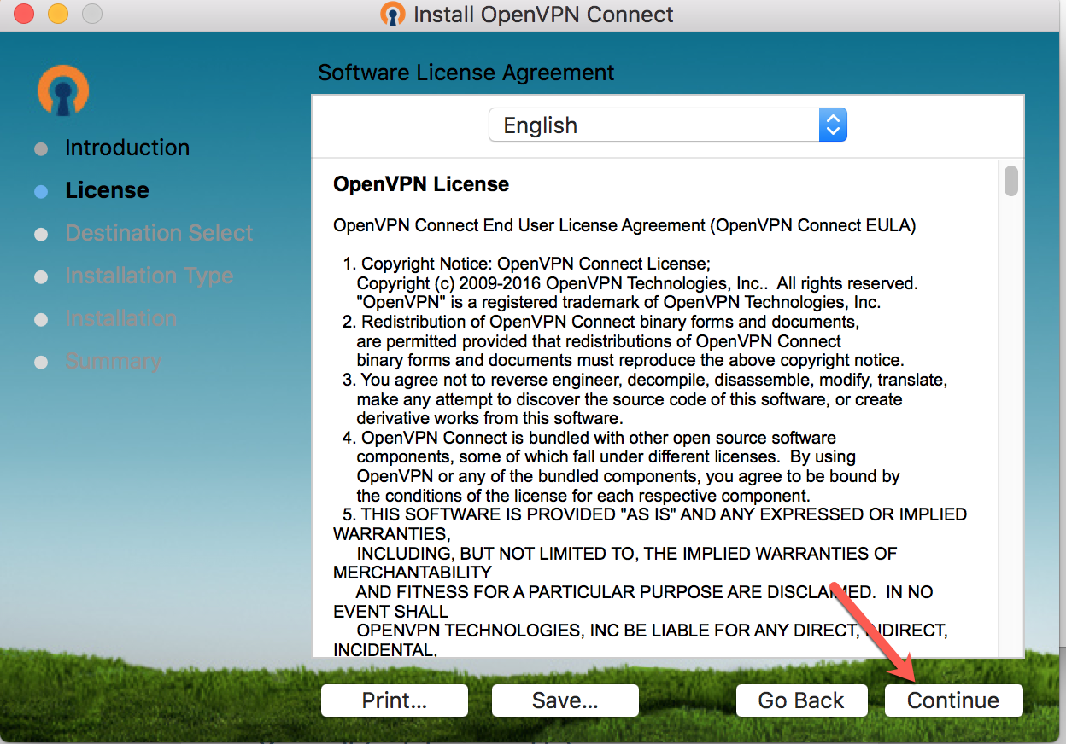
Figure 9 Click Continue
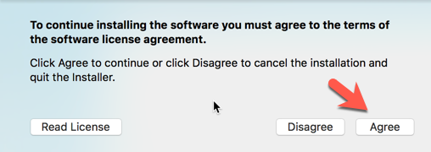
Figure 10 Agree
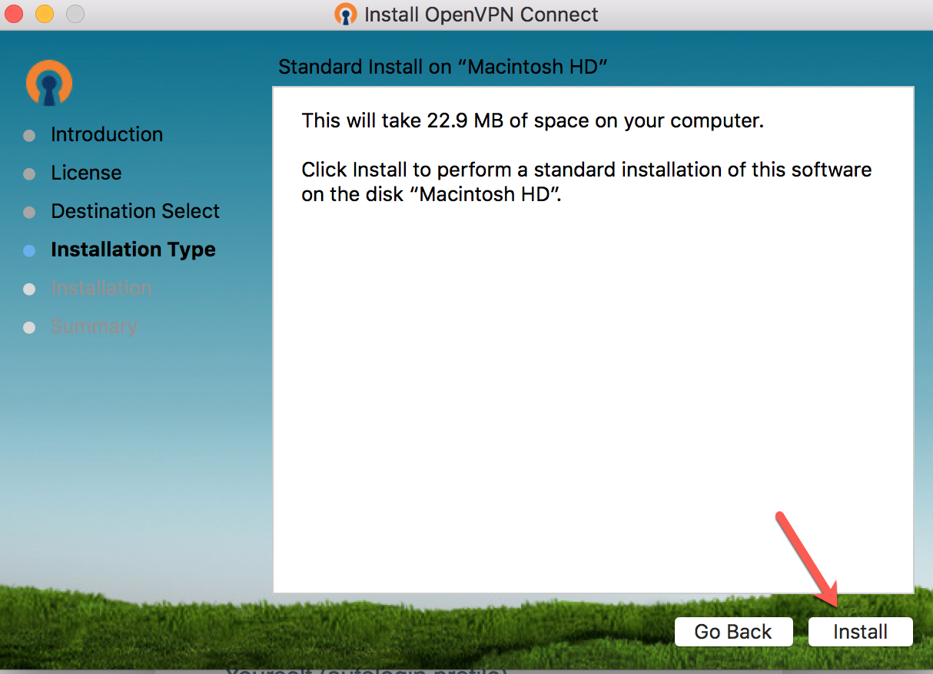
Figure 11 Install
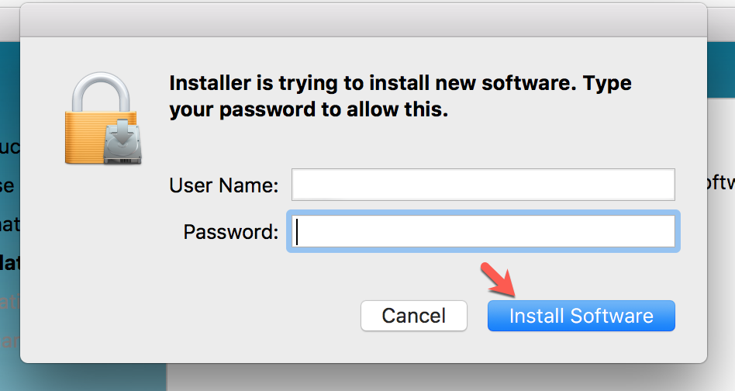
Figure 12 Install
(Note: These are your local MAC credentials)
Note: You may receive a firewall warning.

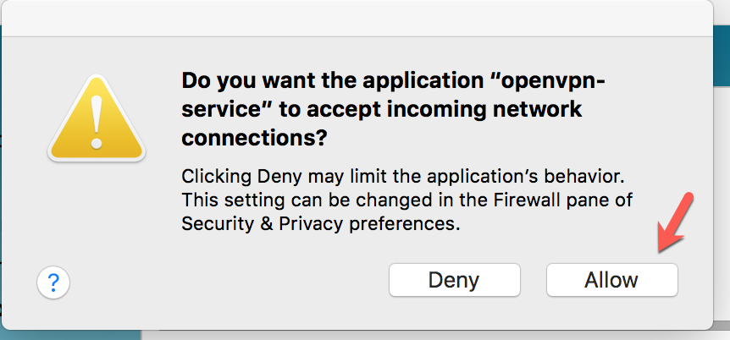
Figure 13 Allow

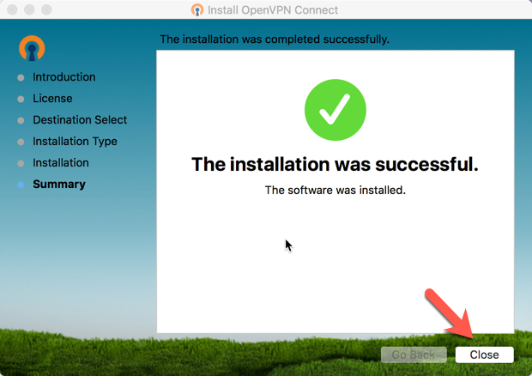
Figure 14 Close
- Verify connectivity, click on the openvpn icon and then Connect to marlin.pilotfishtechnology.com (Fig15-16) Note: Using the openvpn connect client only allows for you to be connected to one vpn at a time.

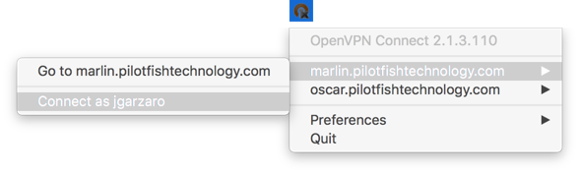
Figure 15 Connect

- If the connection is successful, the icon will turn green. (Fig16-17)

Figure 16
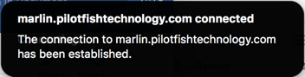

Figure 17

- To disconnect from the VPN, click on the openvpn icon and then disconnect from marlin.pilotfishtechnology.com (Fig18)

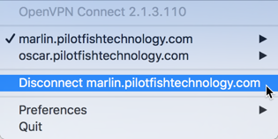
Figure 18 Disconnect

Adding certificate exception Firefox.

- Click Advanced

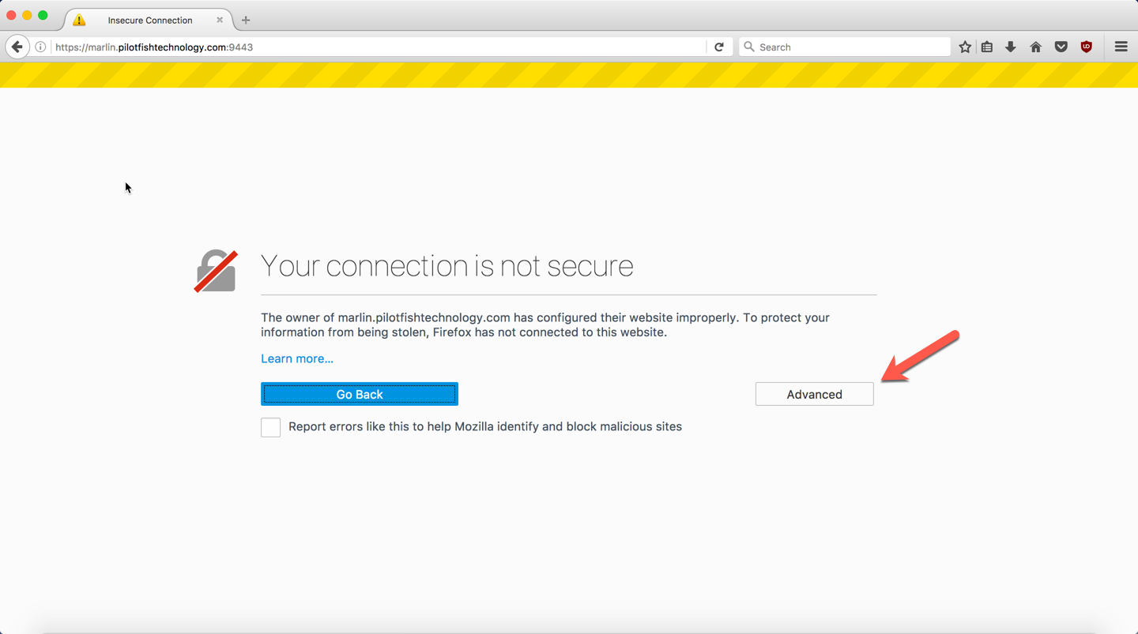
Figure 19
- Click Add Exception
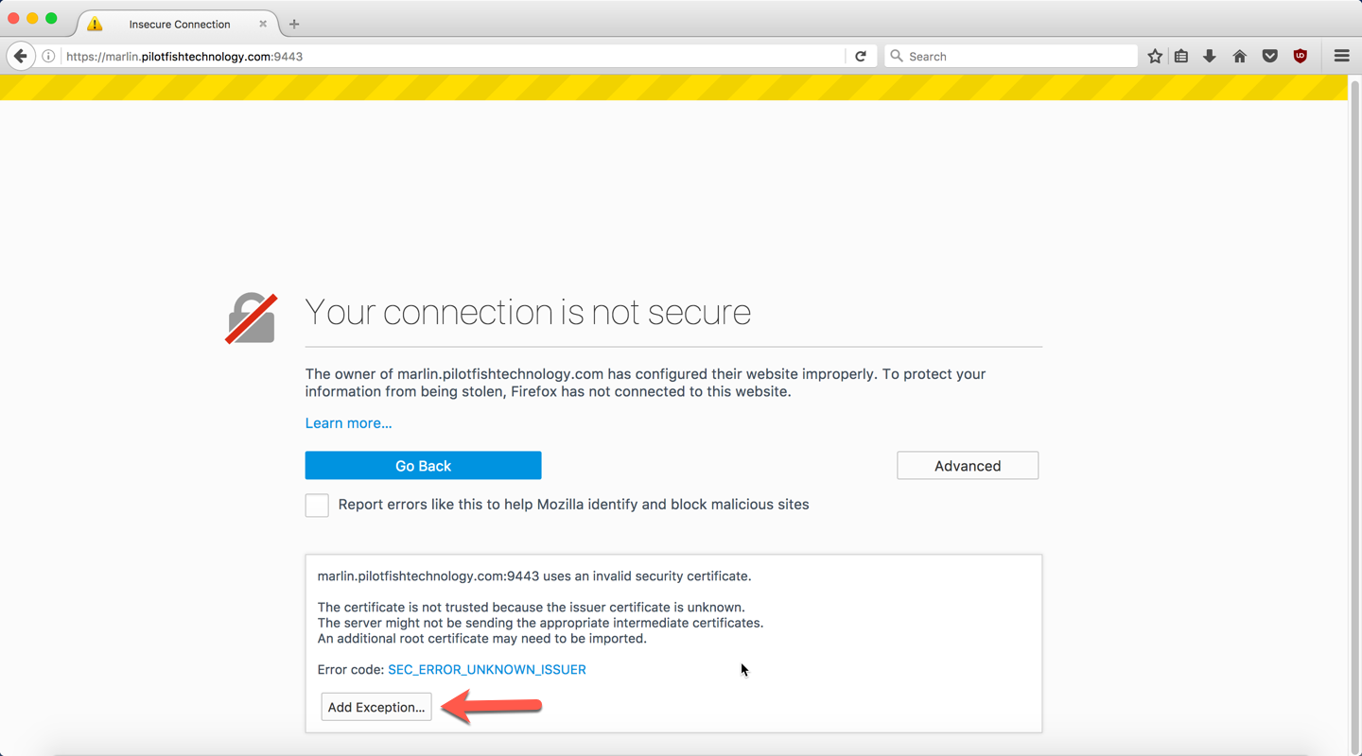
Figure 20
Click “Confirm Security Exception”
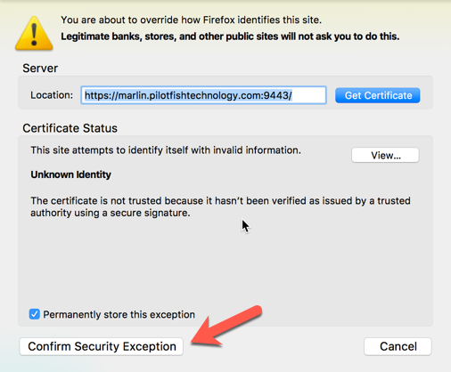
Figure 21

Adding certificate exception Safari

- When prompted click “Continue”

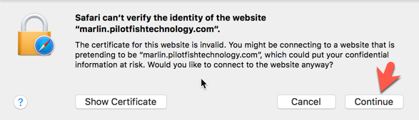
Figure 22

Adding certificate exception Chrome

- Click “ADVANCED”
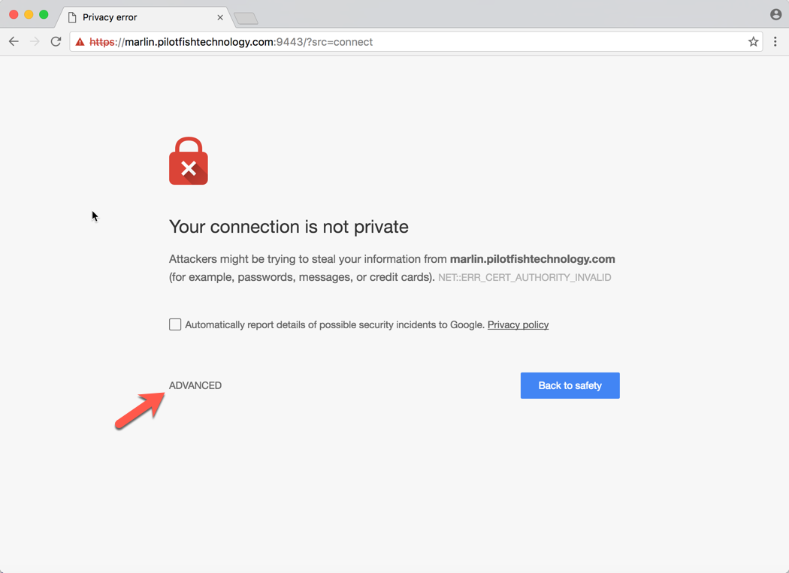
Figure 23

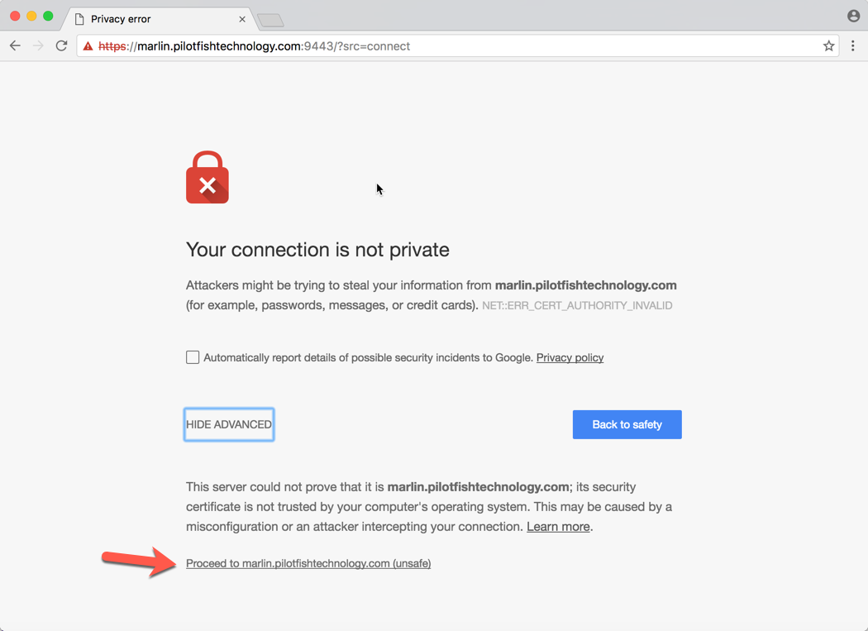
- Click “Proceed to marlin.pilotfishtechnology.com(unsafe)”
Figure 24

