- Click the apple icon (Fig1)

Figure 1

- Click on System Preferences (Fig2)

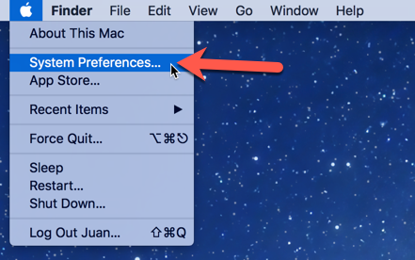
Figure 2

- Click on Time Machine (Fig3)

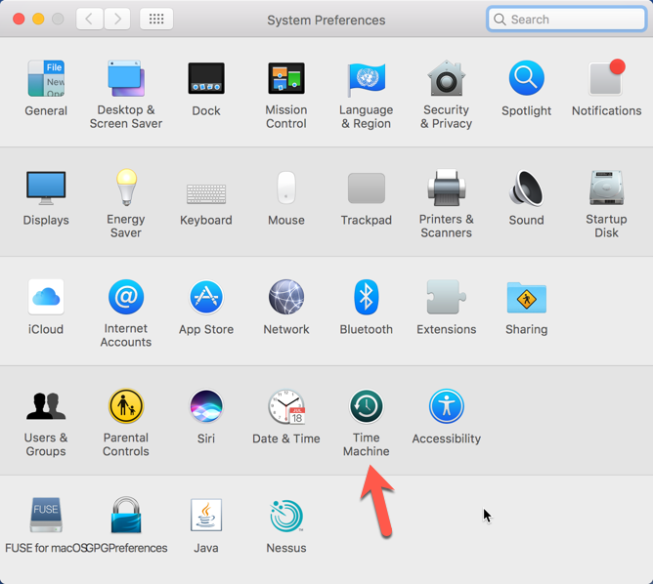
Figure 3
- Click on “Select Backup Disk” (Fig4)

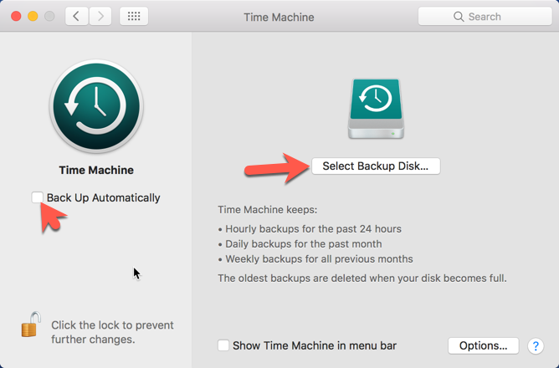
Figure 4

- Select the desired disk that you would like to back up to and click on “Use Disk” This can be a drive attached via usb to the computer, network share, or time capsule. (Fig5)
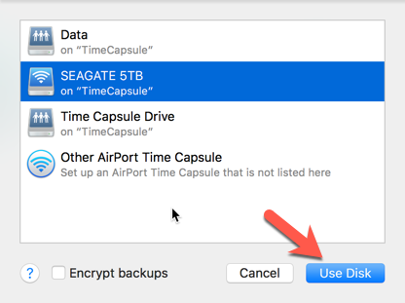
Figure 5
Note: If you would like to encrypt your backups check the box “Encrypt backups” however it is important to note that if you forget/lose your backup password you will not be able to use time machine to restore your data. Click Here for further notes.

- You may be required to enter a password for the “TimeCapsule” Please contact me for the password. (Fig 6)
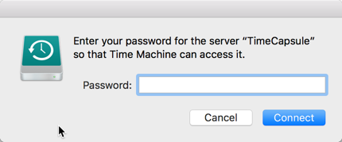
Figure 6

- Make sure that time machine is set to “ON” / “Back Up Automatically” is checked this will vary on your OSX version. (Fig 7 & 8) also check the box “Show Time Machine in menu bar”

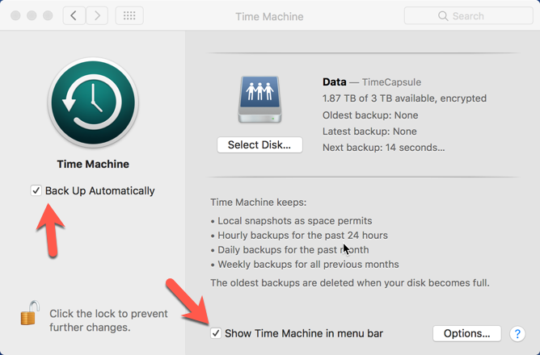
Figure 7

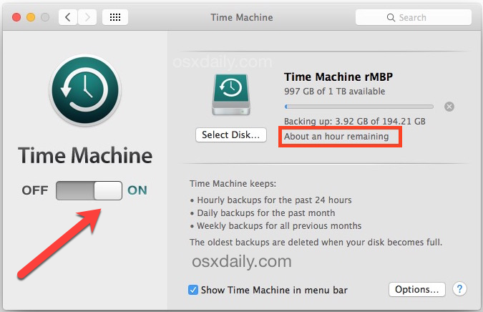
Figure 8

- Excluding files you don’t want backed up. (Fig 9 & 10)

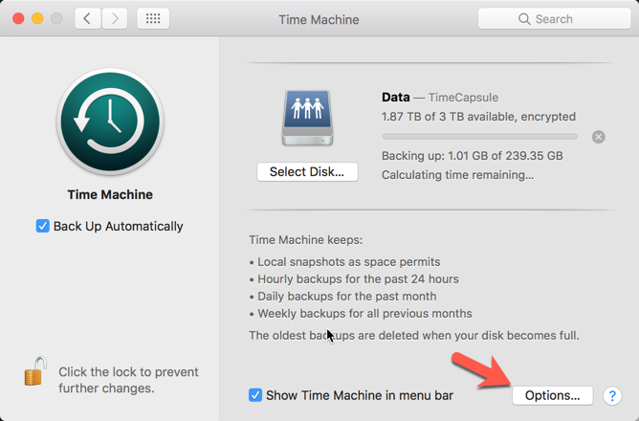
Figure 9

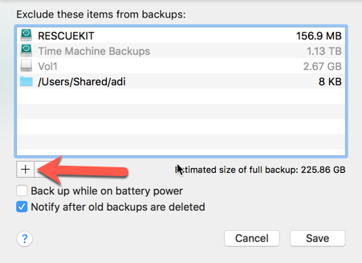
Figure 10

- Select folder or file you’d like to exclude and then click “Exclude” (Fig11 & 12)
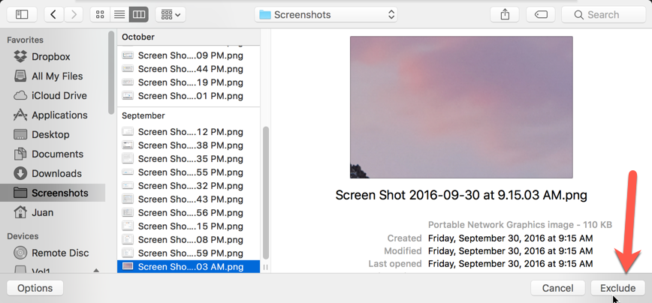
Figure 11
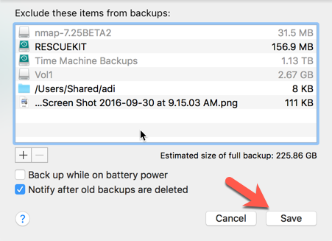
Figure 12

- Entering the time machine.
- Choose Enter Time Machine from the Time Machine menu , or click Time Machine in the Dock.
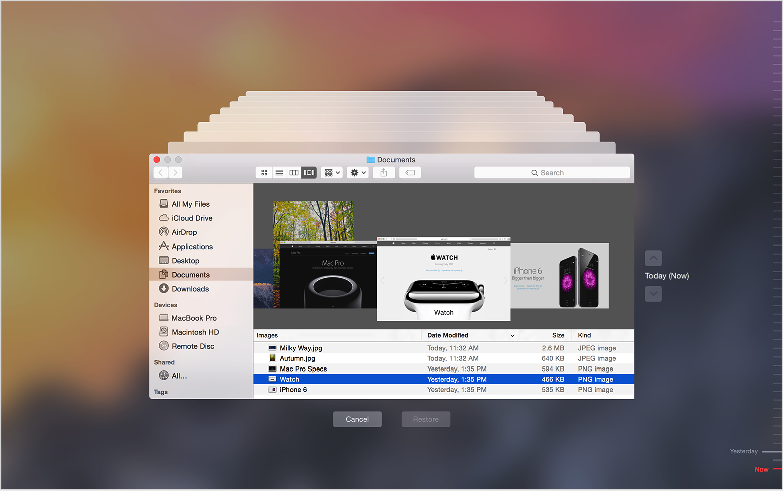
- Find the files to restore:
  - Use the timeline on the edge of the screen to see the files in your Time Machine backup as they were at that date and time. The timeline may also include local snapshots.
  - Use the onscreen up and down arrows to jump to the last time the contents of the window changed. You can also use the search field in a window to find a file, then move through time while focused on changes to that file.
  - Select a file and press Space Bar to preview the file and make sure it's the one you want.
- Click Restore to restore the selected file, or Control-click the file for other options.
Restore everything:
- To restore everything in your Time Machine backup, use macOS Recovery.
- To copy the files, settings, and user accounts in your backup to another Mac, use Migration Assistant.

Notes:

Encrypt backups prompt. If you checked the box for encrypt backups you will see this dialog.

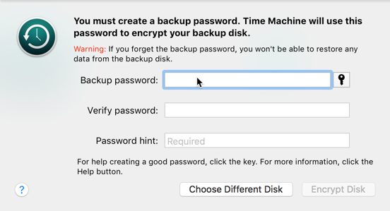

If your backup disk is formatted in a non-mac format you will see this prompt. DO NOT CLICK ON ERASE if the drive has any important data on it as it will erase it. However, if the drive does not have any important information on it and you would like to use it as your backup drive click on “Erase”

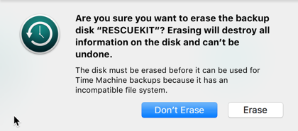

Backup to Multiple Locations.

You can also backup to multiple drives/locations so say you’d like to back up to a time capsule and to a usb disk. You would connect the USB disk open the time capsule preferences and select the secondary disk you’d like to use. It will then prompt you if you’d like to use both.

